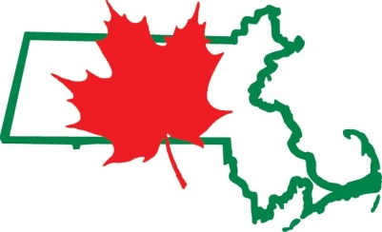
Massachusetts Maple Producers Association
PO Box 6
Plainfield, MA 01070
413-628-3912
info@massmaple.org
www.massmaple.org

2020 Field Trip Grants
MMPA is offering grants of up to $250 to help defray the costs of transportation for school field trips to sugarhouses during the 2020 sugaring season (late February-early April). Please answer these questions and send your responses to winton@massmaple.org by January 15, 2020.

Teacher name:
Email address:
Phone number:
School name:
School town:
Student age range/grade (because these are active farms with some hazardous areas, we recommend that students be age 10 or above):
Number of students:
Will the trip be integrated into your curriculum? What subjects (science, agriculture, etc.)?
Have you visited a sugarhouse with a class in the past? Which sugarhouse?
Do you have a particular sugarhouse you would like to visit, or would you like suggestions? (Visits must be to MMPA member sugarhouses – see list at www.massmaple.org.)
Please take a look at the map of sugarhouses at http://www.massmaple.org/map.php, and note that sugarhouses are not evenly distributed around the state. How far is your group willing to travel to visit a sugarhouse?
Due to changing weather, it is often difficult to know in advance what days a sugarhouse will be making syrup. Can you have a flexible schedule, confirming the trip just a day or two in advance, or do you need to confirm the date farther in advance?
What is the cost of a bus for a field trip such as this?
Anything else you'd like us to know about your class or your field trip plans?

Thanks for your interest. Grant decisions will be made by February 20. If you have any questions, please contact Coordinator Winton Pitcoff at winton@massmaple.org.

